

ACKNOWLEDGEMENT

I would like to place on record my deep sense of gratitude to Mr Ravinder Ahuja, Assistant Professor, Jaypee Institute of Information Technology, India for his generous guidance, help and useful suggestions.

I also wish to extend my thanks to my seniors and other classmates for their insightful comments and constructive suggestions to improve the quality of this project work.

Signature(s) of Students

Ayush Govil (9914103159)
Saurabh Shamra (9914103166)
Karthik Venkataraman (9914103168)
Rohan Gupta (9914103181)

ABSTRACT

Social media and microblog tools are increasingly used by individuals to express their feelings and opinions in the form of short text messages. Detecting emotions in text has a wide range of applications including identifying anxiety or depression of individuals and measuring well-being or public mood of a community. In this project, we propose a new approach for automatically classifying text messages of individuals to infer their emotional states. To model emotional states, we utilize the well-established Circumplex model that characterizes affective experience along two dimensions: valence and arousal. We select Twitter messages as input data set, as they provide a very large, diverse and freely available ensemble of emotions. Using hash-tags as labels, our methodology trains supervised classifiers to detect multiple classes of emotion on potentially huge data sets with no manual effort. We investigate the utility of several features for emotion detection, including unigrams, emoticons, negations and punctuations. To tackle the problem of sparse and high dimensional feature vectors of messages, we utilize a lexicon of emotions. We have compared the accuracy of several machine learning algorithms, including SVM, KNN, Decision Tree, and Naive Bayes for classifying Twitter messages. Our technique has an accuracy of over 90%, while demonstrating robustness across learning algorithms.

Gantt chart

SYNOPSIS

LITERATURE
SURVEY
OPTIMIZATION
CODE
DEBUGGING

VALIDATION AND
DOCUMENTATION
DATE | MARCH  2,2017 | MARCH  4,2017 | MARCH  7,2016 | MARCH  13,2017 | MARCH  15,2017 | MARCH  19,2017

TABLE OF CONTENTS
Page No.

Acknowledgement i
Abstract ii
Gantt Chart iii
List of Tables iv

Chapter 1: INTRODUCTION 1
1.1: DOCUMENT PURPOSE 1
1.2: PRODUCT SCOPE 1
1.3: INTENDED AUDIENCE AND DOCUMENT –OVERVIEW 1
1.4: DEFINITIONS 1

Chapter 2: OVERALL DESCRIPTIONS 2
2.1: PRODUCT PERSPECTIVE 2
2.2: PRODUCT FUNCTIONALITY 2
2.3: USERS AND CHARACTERISTICS 2
2.4: OPERATING ENVIRONMENT 2
2.5: DESIGN AND IMPLEMENTATION CONSTRAINTS 2
2.7: ASSUMPTIONS AND DEPENDENCIES 2

Chapter 3: SPECIFIC REQUIREMENTS 3
3.1: EXTERNAL INTERFACE REQUIREMENTS 3
3.2: FUNCTIONAL REQUIREMENTS 3
3.3: NON-FUNCTIONAL REQUIREMENT 3

Chapter 4: PRESENT WORK 4

Chapter 5: CONCLUSION AND FUTURE SCOPE 5
5.1: FUTURE SCOPE 5
5.2: DATA FLOW DIAGRAM 5

References 6

APPENDIX A - REFERENCE PAPER SUMMARY 7

LIST OF FIGURES

Figure Title Page

1 Data Flow Diagram
2 Use case Diagram
3 ER Diagram

INTRODUCTION

1.1 Purpose of this Document

This is the Software Requirement Specification (SRS) document for the project based on Emotion Detection using Machine Learning. This SRS provides an overview of the project for the client, and more detailed specification for developers. This document discusses the project goals, parameters, target audience, and requirements. This document also describes the brief functional and non-functional requirements for the project.

1.2 Project Scope

Our objectives can be mainly classified as mood analysis and mood prediction. We want to analyze the subject’s current mood. To achieve accurate results we are going to use the subject’s twitter tweets. Tweets are a good source for determining ones sentiment. These sentiments could further be well utilized to possibly predict how the subject would be feeling later in the day.

The scope of the project could be seen as fairly broad as the field of mood prediction is yet to be researched well and the application could be really useful. Knowing who how one would be feeling at a certain point of time in the future, can aid one to prevent terrible meetings, plan special occasions at a better time or even let a second user to find another better time to talk to their dear ones.

1.3 Intended Audience and Document Overview

This document is intended for the client and the faculty member. The rest of the SRS contains a description of the project that makes the reader understand the project well.

1.4 Definitions

ML : Machine Learning

OVERALL DESCRIPTION

2.1 Product Perspective

Social networks and microblogging tools such as Twitter allow individuals to express their opinions, feelings, and thoughts on a variety of topics in the form of short text messages. These short messages (commonly known as tweets) may also include the emotional states of individuals (such as happiness, anxiety, and depression) as well as the emotions of a larger group (such as opinions of people in a certain country or affiliation). In fact, Twitter can be considered a large repository that includes a rich ensemble of emotions, sentiments and moods.

This project provides a means to detect the emotions from a tweet. In particular the project discusses the application of Support Vector Machines, Naive Bayes, KNN and decision tree in detail along with the benefits and pitfalls of each method.

2.2 Product Functionality

Major functions of the system is to detect the emotions, compare the accuracy of other algorithms in detection and analyzing the mood of the user.

2.3 Users and Characteristics

The target client users include the general public. Within general public wide range of personalities exist. Some examples are listed below:

Mark, who is a psychology student can test his theories by tweeting and matching the emotion detected with his theories.

Rose often spends her time on social network. She can find the emotion of other users.

2.4 Operating Environment

The product will run on a PC with: python 2.7, NumPy, Matplotlib, Scikit-learn, pickle, NLTK.

2.5 Design and Implementation Constraints

To get the most appropriate result, we have used different algorithms to detect emotion which would yield us quite an accurate result.

2.6 Assumptions and Dependencies

NumPy1.8.0, Matplotlib1.3.0, and Python 2.7.11, Scikit-learn 0.18.0, should be installed in the Computer.

SPECIFIC REQUIREMENTS

3.1 External Interface Requirements

Following are the External Interface Requirements:

3.1.1 User Interfaces

A proper user interface will be provided to detect emotion for the required user and the corresponding accuracy for each algorithm detecting the emotions.

Hardware Interfaces
Client Side
RAM: 1 GB
Processor: Intel i3(3rd generation)
Disk Space: 320 GB
Server Side

RAM : 2 GB
Processor : Intel i5 (5th generation)
Disk Space : 500 GB

Software Interfaces
Client on internet
Web Branch (IE 10 or newer, Chrome etc.), Operating System (any)
Database Server
Operating System (any)
Web Server

Operating System (any)
Development End
Python, HTML, OS (Windows)

  - Functional Requirements

The product should be platform independent. It should be usable within almost any computing environment.

The emotion detection should be as accurate as possible.

It should cover most of the emotions.

3.3 Non Functional Requirements

Use inbuilt function of NumPy, Sk-learn and Matplotlib.

The system should not lag much due to multiple windows.

Use appropriate algorithms for thresholding, background extraction, and morphological transformation.

PRESENT WORK

So far, we have made all the python scripts needed and made an interface which would detect the emotions of a user by applying 4 algorithms namely Naive Bayes, KNN, SVM, Decision Tree. We have also calculated the accuracy of each one. In the process, when extracting the tweet of a user we have also done preprocessing of the tweet which cleans up the tweet on which all the algorithms are applied.

CONCLUSION AND FUTURE SCOPE

*Conclusion in progress

Future Scope

In future, we intend to suggest the user some methods to change his mood if he is angry and suggest some ways to change his mood by providing useful information from the Internet and suggesting some of his favorite things that he/she would do while being not in a good mood. We intend to analyze the temporal nature of emotions and investigate how they change over time. We are also interested in population level emotion detection in divergent subgroups like divergent genders, or ages. In addition, we intend to integrate other pieces of information such as, sleep data, exercise and physical activities, and food information.

Data Flow Diagram

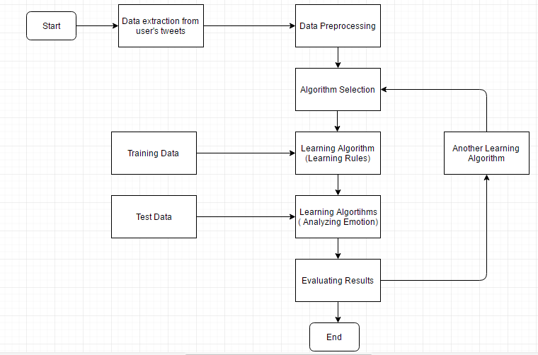

  - Use Case Diagram
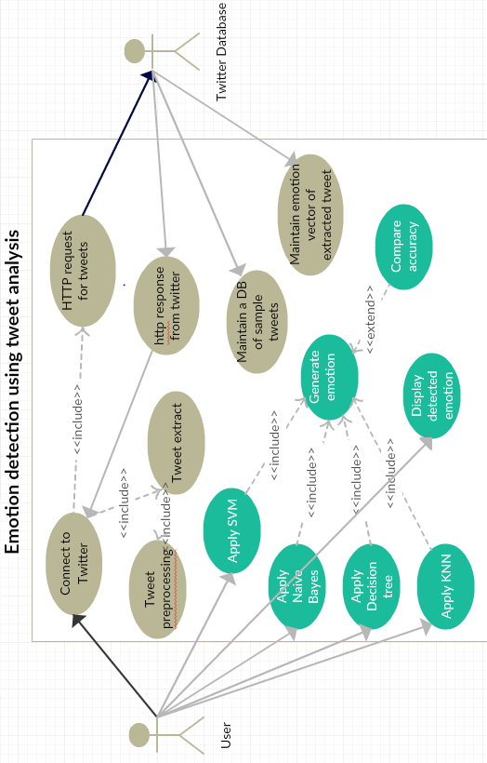
  - E-R Diagram
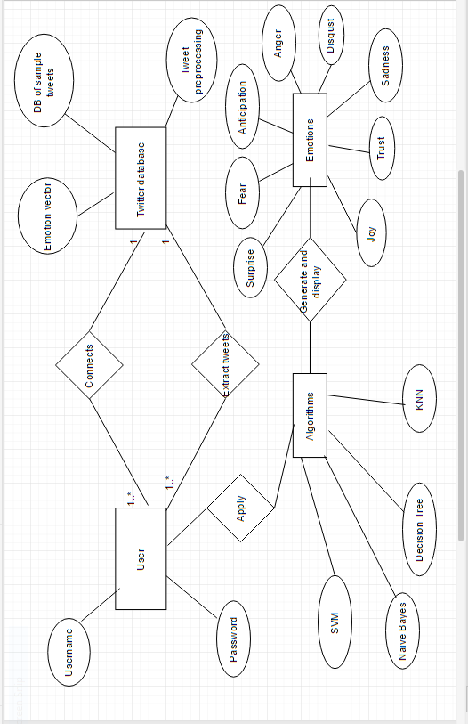

REFERENCES

BOOK

[1] Sebastian Raschka, Python Machine Learning. New York: Packt Publishing,2015

JOURNAL ARTICLE

[2] Kirk Roberts, Michael A. Roach, Joseph Johnson, Josh Guthrie, Sanda M. Harabagiu: EmpaTweet: Annotating and Detecting Emotions on Twitter. In Human Language Technology Research Institute,University of Texas at Dallas

ONLINE

[3] Twitter Data Preprocessing

https://www.analyticsvidhya.com/blog/2014/11/text-data-cleaning-steps-python/

PROCEEDINGS PAPER

[4] Maryam Hasan, Elke Rundensteiner, Emmanuel Agu, “EMOTEX: Detecting Emotions in Twitter Messages,” in Computer Science Department, Worcester Polytechnic Institute, 2013.

TECHNICAL REPORT

[5] R. Cox and J. S. Turner, “Project Zeus: design of a support vector machines and its applications,” Washington Univ., Dept. of Comp. Sci., Technical Report WUCS-91-45, July 30, 1991

APPENDIX A- RESEARCH PAPER SUMMARY

Research Paper 1: EMOTEX: Detecting Emotions in Twitter Messages

Published in- Computer Science Department, Worcester Polytechnic Institute

Publisher: IEEE

Authors: mhasan@wpi.edu, rundenst@cs.wpi.edu, emmanuel@cs.wpi.edu

Abstract

Social media and microblog tools are increasingly used by individuals to express their feelings and opinions in the form of short text messages. Detecting emotions in text has a wide range of applications including identifying anxiety or depression of individuals and measuring well-being or public mood of a community. In this paper, we propose a new approach for automatically classifying text messages of individuals to infer their emotional states. To model emotional states, we utilize the well-established Circumplex model that characterizes affective experience along two dimensions: valence and arousal. We select Twitter messages as input data set, as they provide a very large, diverse and freely avail- able ensemble of emotions. Using hash-tags as labels, our methodology trains supervised classifiers to detect multiple classes of emotion on potentially huge data sets with no manual effort. We investigate the utility of several features for emotion detection, including unigrams, emoticons, negations and punctuations. To tackle the problem of sparse and high dimensional feature vectors of messages, we utilize a lexicon of emotions. We have compared the accuracy of several machine learning algorithms, including SVM, KNN, Decision Tree, and Naive Bayes for classifying Twitter messages. Our technique has an accuracy of over 90%, while demonstrating robustness across learning algorithms.

Introduction

Social networks and microblogging tools such as Twitter allow individuals to express their opinions, feelings, and thoughts on a variety of topics in the form of short text messages. These short messages (commonly known as tweets) may also include the emotional states of individuals (such as happiness, anxiety, and depression) as well as the emotions of a larger group (such as opinions of people in a certain country or affiliation). In fact, Twitter can be considered a large repository that includes a rich ensemble of emotions, sentiments and moods. For example the tweet "Great Christmas spent with my amazing family" expresses a happy mood and the tweet "Feelings Hurt Tonight!" expresses sadness.

Background

In this paper, we investigate a method for automatically detecting and classifying the emotions expressed by Twitter messages. A system developed based on this method could potentially be employed in a large variety of applications, ranging from well-being apps, self-helps, counsellors, to community population studies. The proposed method can be used by healthcare professionals or counselling agencies to monitor and track a patient's emotional states, or to recognize anxiety or systemic stressors of populations (e.g. different student groups on campus). The system can also help commercial agencies to gauge sentiment of buyers or to facilitate targeted product advertisement. In addition, this technology can measure public mood of people in a community, which may help social scientists to understand the quality of life of populations. Measuring and tracking the living conditions and quality of life of a society are essential for public policy making. The quality of life can be measured based on different aspects of life including social, emotional, psychological, life satisfaction, and work. However, methods that measure living conditions fail to measure what people think and feel about their lives, such as their positive or negative emotions, or their overall satisfaction with life. The quality of life is typically measured using self-reports and surveys. People are asked to fill out questionnaires about their life and their day-to-day emotions. Collecting these questionnaires is very time consuming, tedious, and error-prone. However, the system developed based on our proposed approach would be able to automatically detect what people feel about their lives from twitter messages. For example, the system can recognize:

- Percentage of people expressing higher levels of life satisfaction in one group versus another group,

- Percentage of people who feel happy and cheerful,

- Percentage of people who feel calm and peaceful, and

- Percentage of people expressing higher levels of anxiety or depression.

Classifying text messages based on their emotion or sentiment is a growing area of research. However, although some prior work has been done to classify Twitter messages (see related work in Section 5), most of them have focused on determining message sentiment instead of emotion [6, 7, 8, 9]. Sentiment refers to the opinions of individuals about a topic (e.g. a movie or a new product). Sentiment is categorized either as positive or negative. Our goal instead is to provide an approach for automatically and accurately classifying Twitter messages into distinct emotional categories. To represent classes of emotion, we adopt the Circumplex model, a popular model of human emotions, which characterizes affective experience through two dimensions: valence and arousal. Instead of classifying tweets into two classes (positive or negative) as in sentiment analysis, we design methods to detect and classify short text messages into four finer-grained classes of emotion.

1.4 EMOTEX: Our Proposed Approach

Our proposed approach resolves the challenges mentioned in previous section as following:

To support casual Twitter language and noise: correct misspellings and casual language by pre-processing all Tweets with clearly defined rules.

To label Tweets: use Twitter hash-tags as labels that indicate the emotion expressed by Tweets. For example, a tweet with the hash-tag "#depressed" is labelled as one expressing a depressed emotion, while a tweet containing the hash-tag "#excited" is labelled as expressing excitement. Using the Twitter API, we collected a large number of tweets with hash-tags that then served as noisy labelled data. While hash-tags can themselves cause errors or be ambiguous when utilized as labels, they enable the automatic processing of tweets that would otherwise take hours or days to label manually. After extracting enough labelled data, the hash-tags were removed in order to force the classifier algorithm to learn from other features.

To avoid high dimensional and sparse feature vectors: use a lexicon of emotions. Our dictionary does not include all words in the training dataset, but instead it focuses on the emotional words from the lexicon LIWC (Linguistic Inquiry & Word Count: http://www.liwc.net/). The LIWC contains several thousand words. We use emotion-indicative categories such as positive emotions, negative emotions, anxiety, anger and sadness to build our domain-specific dictionary.

In particular, EMOTEX makes the following contributions:

-Designing and implementing a method to automatically label twitter messages according to the emotions of their authors.

-Resolving the problem of high dimensional feature space in twitter dataset.

-Achieving highest accuracy for classifying twitter messages based on their emotional states.

The rest of the paper is organized as follows. Section 2 describes the model that we exploit to categorize emotional states of individuals. In section 2 we describe our proposed approach in Emotex. In section 4 we present our experiments and discuss the results. In Section 5 we discuss prior work on sentiment analysis and emotion analysis on micro-blog data. We conclude and give future directions of research in section 6.

2.1 Model of Basic Emotions

Basic emotion theorists believe that humans have a small set of basic emotions, which are discrete. Various researchers have attempted to identify a number of basic emotions which are universal among all people and differ one from another in important ways. A popular example is a cross-cultural study of 1972 by Paul Ekman and his colleagues, in which they concluded that the six basic emotions are anger, disgust, fear, happiness, sadness, and surprise.

Consequently most work in the field of emotion mining and classification from text has been based on this basic emotion sets [1, 18, 19]. For example, in order to model public mood and emotion, Bollen et al extracted six dimensions of mood including tension, depression, anger, vigour, fatigue, confusion from Twitter [1]. Strapparava and Mihalcea annotated a large data set with six basic emotions: anger, disgust, fear, joy, sadness and surprise [19].

However, there is no consensus amongst theorists on which human emotions should be included in the basic set. Moreover, the distinction of one emotion from another is a contested issue in emotion research. For instance, it is unclear if "surprise" should be considered an emotion since it can assume negative, neutral or positive valence.

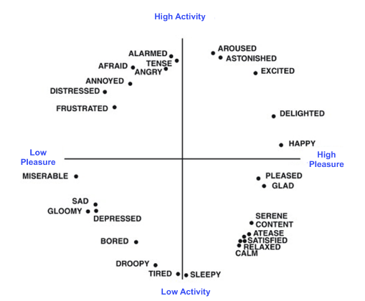

3 EMOTEX: Detecting Emotions in Text Messages

To detect emotions in text messages such as tweets, we apply supervised learning methods to automatically classify short texts, according to a finer-grained category of the emotions.

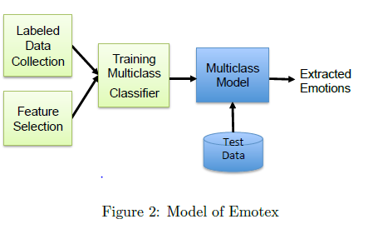

This section describes in more detail how Twitter messages are collected, labeled and classified according to the emotions they convey. Figure 2 shows the process flow of Emotex. We gathered Tweeter messages, selected features and trained classifiers that classify tweets into multiple emotion classes.

3.1 Collecting Labeled Data

Twitter message features such as hash-tags and emoticons are likely to be useful features for sentiment and emotion classification. The usage of hashtags in tweets is very common, and Twitter dataset contains millions of different user-defined hash-tags. A study of a sample of 0.6 million tweets by Wang et al. [21] showed that 14.6% of tweets in their sample had at least one hashtag. Many tweets include more than a single tag. These hash-tags could help to group messages that indicate a certain emotion. Our results (see Section 4) confirms that hash-tags are indeed useful features for sentiment and emotion classification. In order to collect labeled data, we need to identify the list emotion hash-tags. First, we exploit the set of 28 affect words from Circumplex model (as shown in Figure1) as initial set of keywords. Then we extend the initial keywords using WordNet's synsets, and we use them to find emotion hash-tags. Using the list of emotion hash-tags, we collect tweets which contain emotion tags. Twitter has an API that can be used to automatically collect tweets and filter them by query terms or hash-tags. Figure 3 shows the steps of data collection.

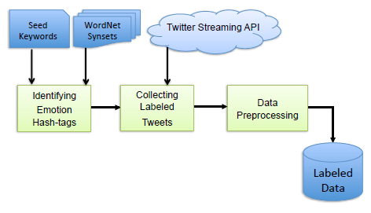

3.1.1 Preprocessing

After collecting the same number of tweets for each class, the labeled tweets are then pre-processed to mitigate misspellings and casual language used in Twitter using the following rules:

1. Tweets often contain usernames which start with the @ symbol before the username (e.g. @Marilyn). All words that start with the @ symbol are replaced by "USERID".

2. Many tweets contain url links. All the url links are replaced with the "URL".

3. Words with repeated letters such as happyyyyy, are common in Twitter messages. Any letter occurring more than two times consecutively is replaced with one occurrence. For instance, the word "happyyyyy" would be changed into "happy".

4. Many tweets contain more than one hash-tag, while some may even contain hash-tags from two different classes. For example the tweet "Got a job interview today with At&t... #nervous #excited.", includes hashtag #nervous from Unhappy-Active class and tag #excited from Happy-Active class. Any tweet containing hash-tags from different classes are removed from training data. Tweet may also be removed if they contain two subjects. Such tweets are removed because they would introduce ambiguities into our training set. We do not want features of one class marked as part of another class. These tweets correspond to a mixture of emotion of different classes; therefore they would mislead our classifier algorithm.

5. Some tweets contain emoticons from two different classes. For example the tweet "Tomorrow, first volleyball match :) and final exam :(", includes both happy and sad emoticons. These tweets are removed during pre-processing.

6. Some tweets contain conflicts between hash-tags and emoticons. For example the tweet "Yup, I'm totally considering leaving this planet now :) #disappointed #nohope", includes hash-tag "#disappointed" from Unhappy-Inctive class and emoticon ":)" which shows happiness. The tweets from unhappy-Inactive class containing happy emoticons as well as tweets from happy-active class containing sad emoticons are removed from labeled data.

7. In Twitter, hash-tags can be placed in the beginning, middle, or end of a tweet. As part of pre-processing, hash-tags are stripped o_ from the end of tweets. For instance, the tags "#disappointed" and "#sad" are removed from the tweet "No one wants to turn up today. #disappointed #sad ". If the tags were not stripped o_, then the classifiers tend to put a large amount of weight on the tags, which may hurt accuracy. However the tags in the beginning or in the middle of the tweet are left, since they are part of the content of the sentence. For example in the tweet "That #nervous but hopeful #feeling that keeps you up at night or makes you get up early" the tags "#nervous" and "#feeling" are part of the sentence and are kept.

4.2 Classification Results

We divided the collected data for each class into three equalsized folds, which used two folds of the labeled data to train a classifier and one fold for testing. Then we learned classifiers out of training data using selected classification algorithms. We used WEKA [25] for Naive Bayes, Decision Tree, and KNN classification, and we used the SVM-light [26] software with a linear kernel to learn SVM classifier. We measured the accuracy of classifiers based on precision and recall. Also, we calculated the F-measure, which is the weighted harmonic mean of precision and recall. Tables 4 and 5 present precision and recall of Naïve Bayes, Decision Tree, SVM, and KNN using different kind of features, based on 3-fold cross validation. Table 4 presents the F-measure as a single measure that trades off precision versus recall. As the table shows, the highest accuracy for Decision Trees and Naive Bayes can be achieved by using all the proposed features. However SVM achieved the highest accuracy by using unigrams, while KNN achieved the highest accuracy by using unigrams and negations.

Although Decision Tree classifier provides high accuracy, it is very slow and therefore not practical for big datasets. KNN and SVM run fast and provide the highest accuracy, above 90%. The accuracy of SVM classification are presented in Figure6. For the class Unhappy-Active and Happy-Active the highest accuracy can be achieved by using all the features. However for other classes the highest accuracy can be achieved by using unigrams. The classes’ happy-active and unhappy-active got the highest accuracy. Interestingly, using punctuation features across these two classes increased the accuracy up to 95% and 91% respectively. Across all emotion classes, unigram-trained model gave the highest performance, and among other features punctuations and negations performed second best. The accuracy of KNN classification based on 3-fold cross validation are presented in Figure 7. As it shows the highest accuracy achieved for the class happy-active. Among all the classifiers KNN achieved the highest accuracy of 90%. 6 Conclusions We have proposed Emotex, a method of classifying Twitter messages into the distinct emotional classes they express. To define the emotional states of users, we utilized the well-established model of human moods, known as the Circumplex model [10]. We employed Twitter hash-tags to automatically label messages according to emotional classes, and trained classifiers for multi-class emotion detection. Our results suggest that hash-tags and other conventional markers of tweets are useful features for sentiment and emotion classification.

We also compared the accuracy of several machine learning algorithms such as SVM, Naive Bayes, KNN, and Decision Tree for classifying the moods of Twitter messages. We were able to achieve above 90% classification accuracy, while demonstrating robustness across different learning algorithms. The proposed Emotex approach enables us to classify large amounts of short texts with no manual effort, yet with high accuracy (above 90%). Classifying short texts according to a finer-grained classes of emotions provides rich and informative data about the emotional states of individuals. These data can be used by healthcare professionals for early detection of the psychological disorders such as anxiety or depression. In the future we intend to analyze the temporal nature of emotions and investigate how they change over time. We are also interested in population level emotion detection in different subgroups like different genders, or ages. In addition, we intend to integrate other pieces of information such as, sleep data, exercise and physical activities, and food information.

CONCLUSIONS

We have proposed an Emotion detector which is a method of classifying Twitter messages into the distinct emotional classes they express. We used the user’s tweets to analyze his mood. We build 2 databases, one for training and other for testing our algorithms. We also cleaned up the tweets by preprocessing them. We build an interface where the person can detect a user’s emotion through different algorithms.

The proposed approach enables us to classify large amounts of short texts with no manual effort, yet with high accuracy (above 90%). Classifying short texts according to a finer-grained classes of emotions provides rich and informative data about the emotional states of individuals.

These data can be used by healthcare professionals for early detection of the psychological disorders such as anxiety or depression.

